**369links android mobile app  
  
This is not at all like an electron app or proper mobile app. all the icons should feel like buttons at least. but UI looks good need slight changes**

1)Poco x4 pro mobile app UI FIXED on 08-05-2023

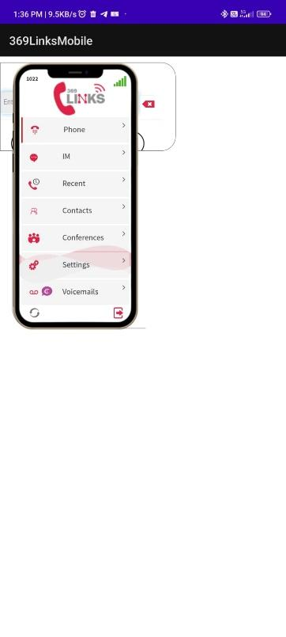

2)first phone tab then recents then IM should be there

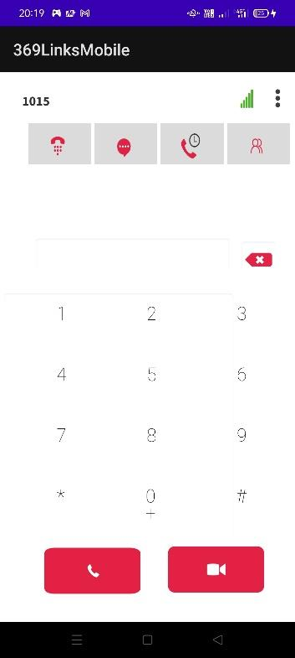

FIXED on 08-05-2023

**3)automatic login page is coming like this need proper one**

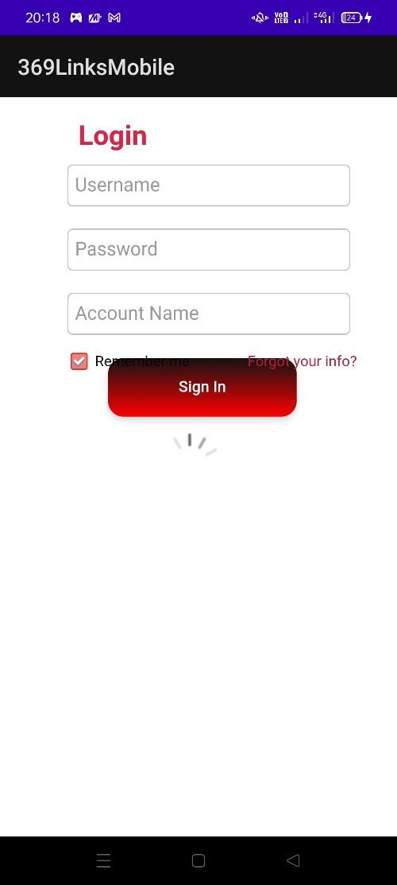

NOT FIXED as on 08-05-2023

4)After sometime main page is coming like this

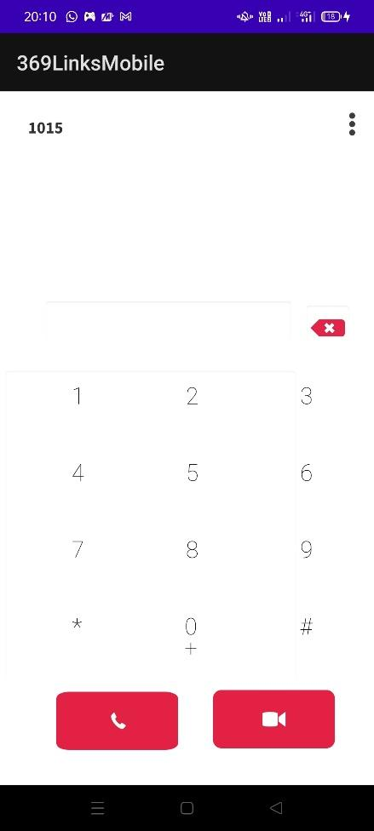

NOT FIXED as on 08-05-2023 after keeping idle for some time and we make any call or go to any page

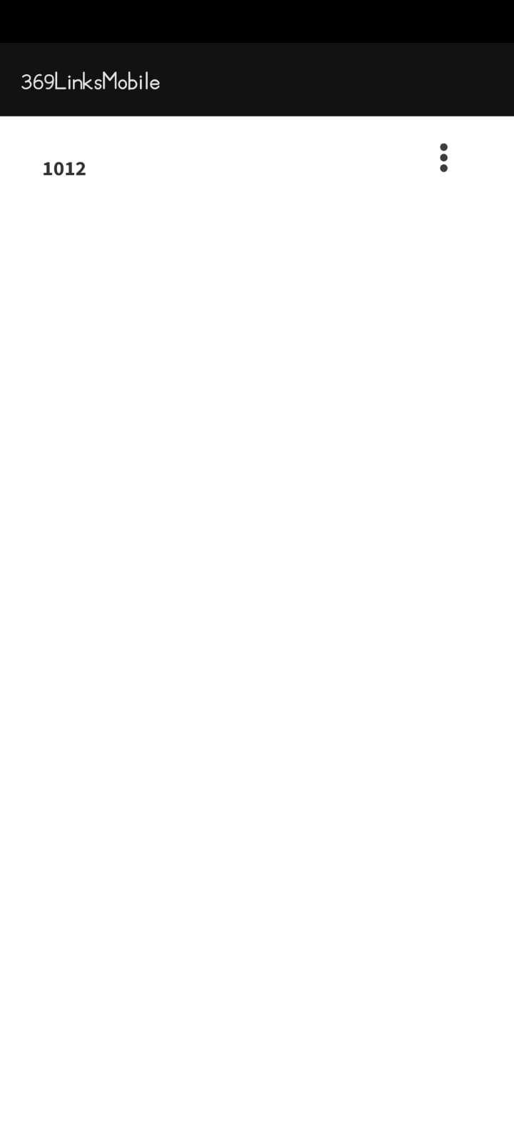

5) Mobile app Voice call incoming and outgoing calls are one way speech cant hear anything on mobile app.  
a) mobile app – microsip : microsip voice is coming but mobile app voice is not coming

b) Mobile app – mobile app both sides no voice.   
NOT FIXED as on 08-05-2023 - Now only incoming popu flashes and goes.. not able to lift the call

|| This is an issue with AWS, and will be moving to phoenix.

6) Numbers are only clickable when we type exactly on a number.. it should have box type clickable



FIXED as on 08-05-2023

7)when we double click on 0/+ :   
NOT ABLE TO CLICK +   
 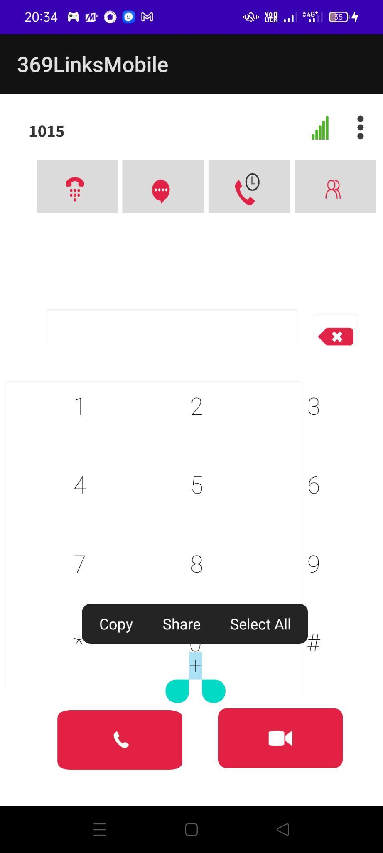

8) Speaker option is not available NOT FIXED as on 08-05-2023

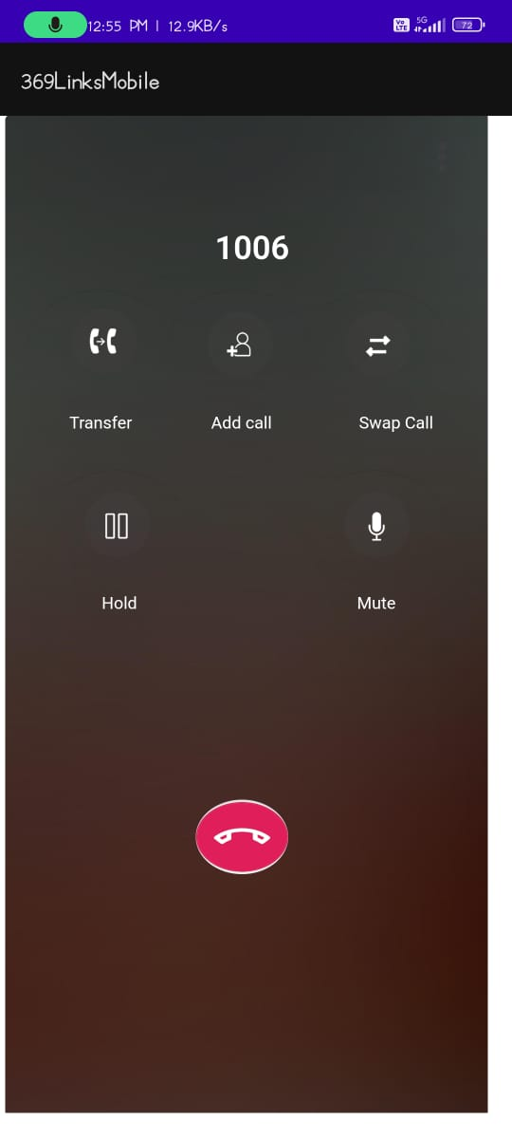

9) On incoming call pop up is coming, it will be better if it gives a proper incoming call page.  
and it is also activating the camera and giving some play button image on background

NOT FIXED as on 08-05-2023 unable to check, unable to answer the incoming call

|| Also because of AWS.

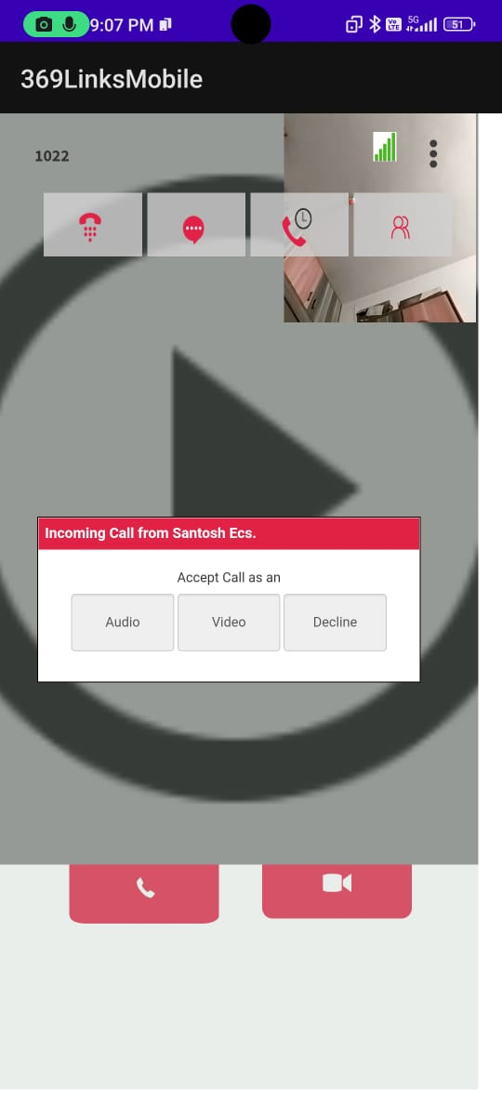

10) No ringtone on incoming call NOT FIXED as on 08-05-2023 getting Default tone of Dt app,

11)when we click on number space keypad also coming which is not required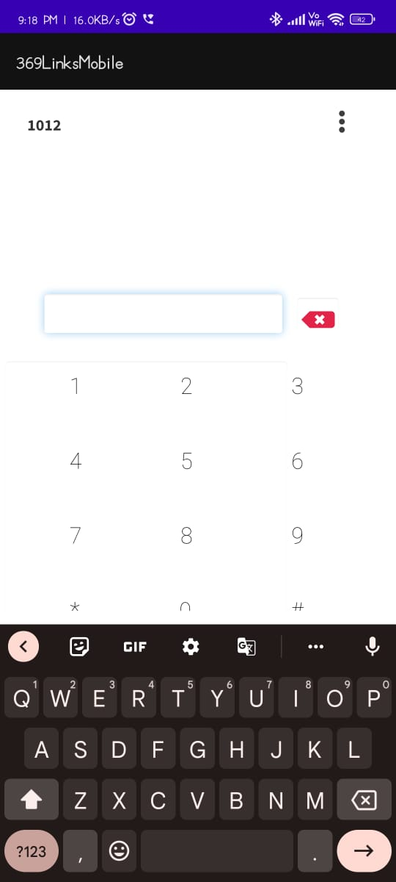

NOT FIXED as on 08-05-2023

12) IM chat page is looking like this  
a) extension number and name is merged FIXED as on 08-05-2023

b) typing message is almost in center

c) IM is not working 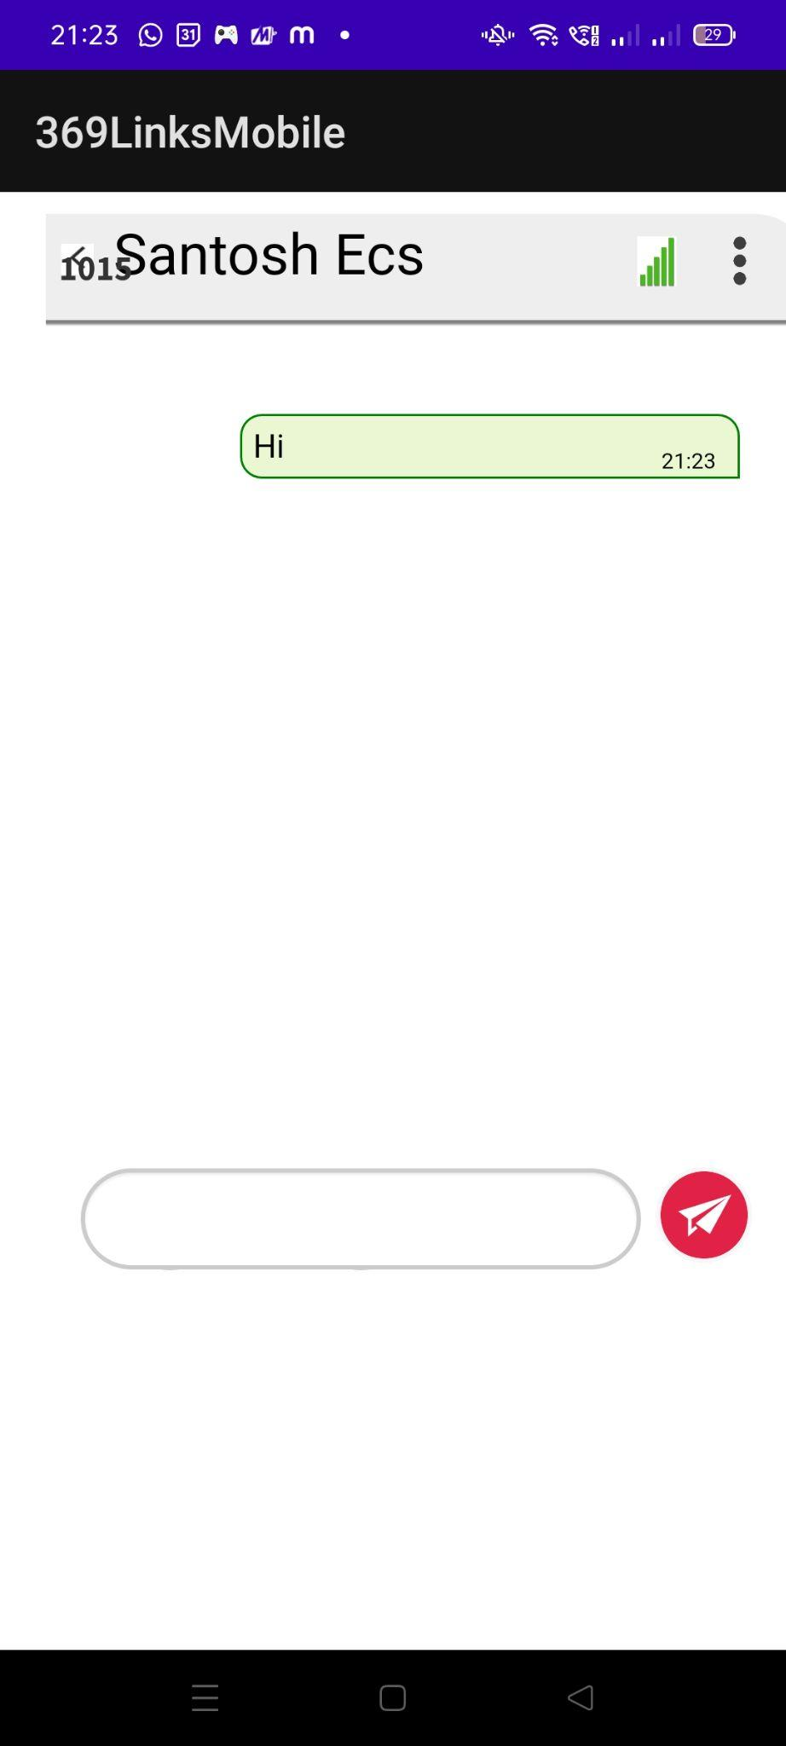

13) Whenever we click the back button on mobile it is not going back to the page, rather it is closing the whole app itself .

On 08-05-2023, the option is not working, it is not going to home page as well as unable to close the app, we have to kill the app and open again

|| How back navigation works is we save the locations of navigated modules in a stack (LIFO style) but since in dtapp we never change the page location so the back button will either close the app directly because no previous location is detected – this was the previous implementation, i have disabled the back button interaction altogether now.

14)Search option in IM is not working NOT FIXED as on 08-05-2023

15) Whenever we initiate a call, in recents it is showing our own extension. needs to show the extension which we tried to call NOT FIXED as on 08-05-2023

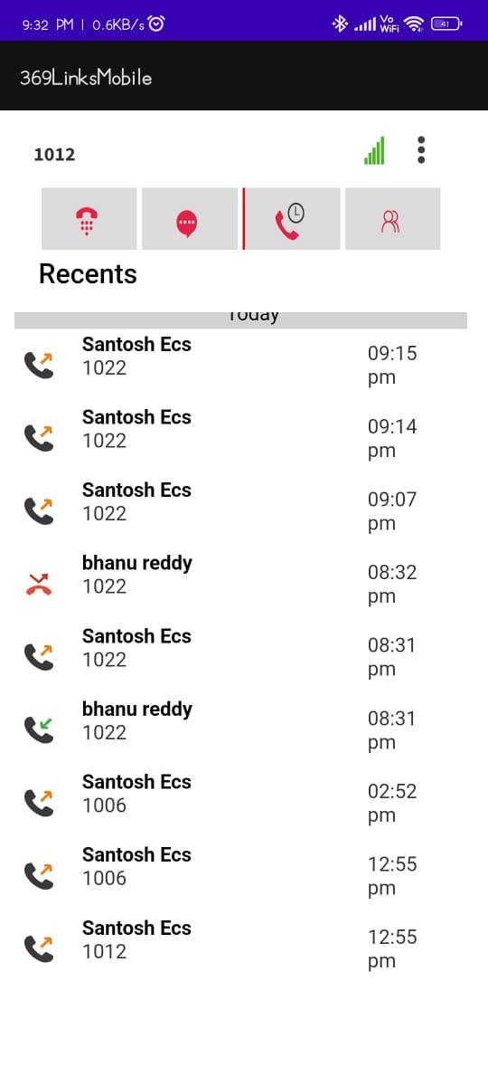

16)There is no refresh button.

17) No option for local contacts and app contacts. NOT FIXED as on 08-05-2023

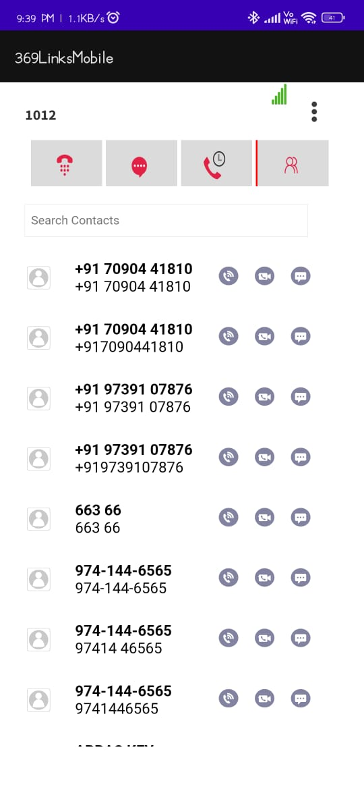

18)when we click on three dots these three options will come but it doesn't hide when we click anywhere on screen but we have to click again on three dots only to hide these options

FIXED on 08-05-2023

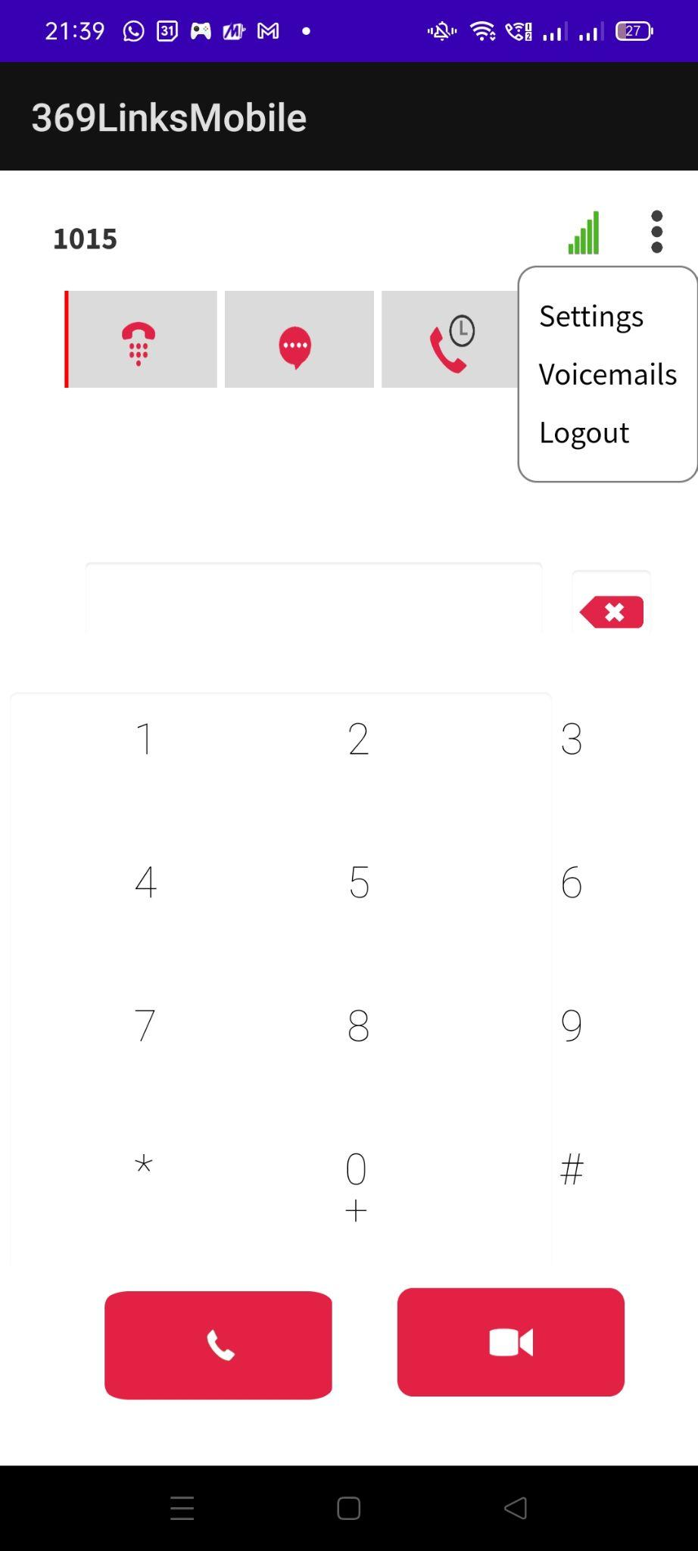

19) if call originated from contacts and Recents, then the call page UI is not so clear NOT FIXED as on 08-05-2023 now getting keypad also

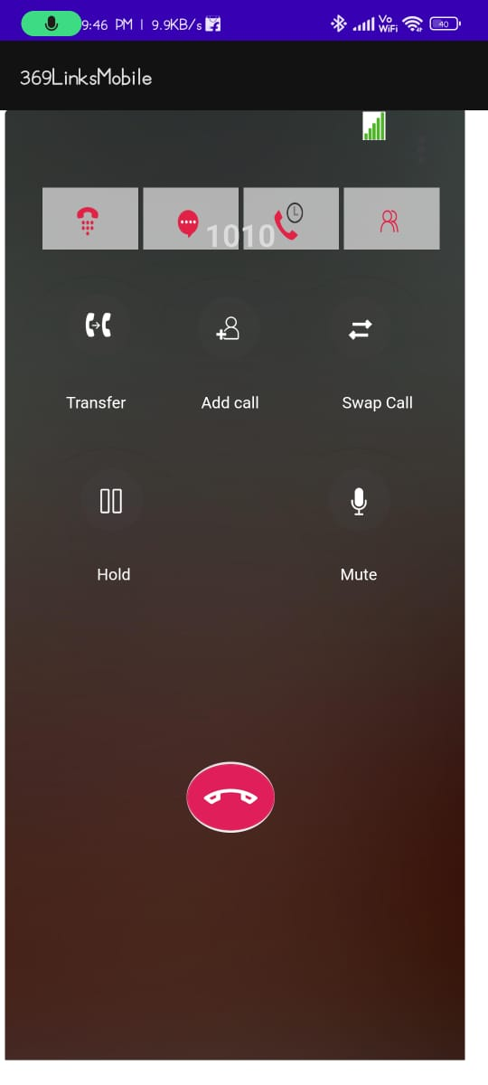

|| Is this for recents or contacts or both? (BOTH)

20)App is not working in Background NOT FIXED as on 08-05-2023

added on 08-05-2023

21) Calling window icons are not arranged properly

22) Need a dialpad on calling window, to press options on any IVR call

23) Long press the delete button to remove all numbers on the numberbox not working.